FINAL PROGRAMME
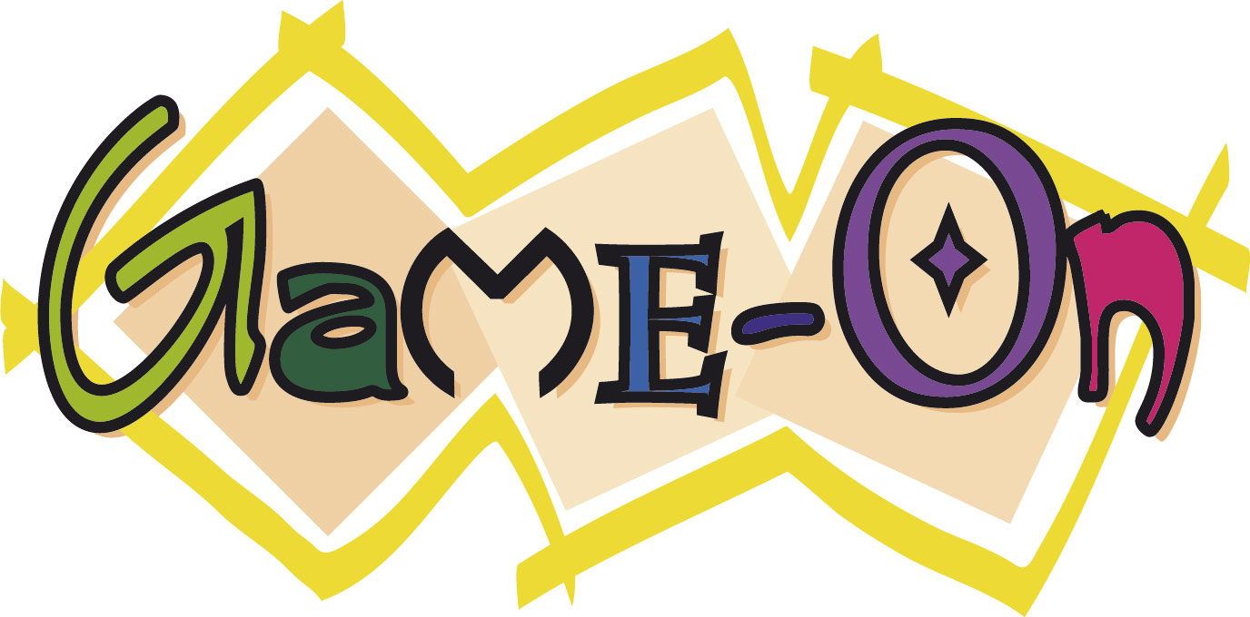
22 – 23 August 2011

National University of Ireland,
Galway, Ireland

Organised by

Sponsored by
 |  | 
 |  | 
 |  | 
GAME-ON'2011 FINAL PROGRAMME

Overhead and LCD Projector are standard
The underlined authors are usually the presenters.
Conference Site: NUI, IT Building, Room IT202, Galway. The way to the meeting room will be signposted. Wireless will be available.

Monday, August 22, 2011

08.30 - 15.00 Registration in front of the meeting room

09.00 - 09.15 Welcome:
Welcome Address
Colm O’Riordan, National University of Ireland, Galway, Ireland
Prof. Gerard Lyons, National University of Ireland, Galway, Ireland

09.15 - 10.00 Session I

INVITED SPEAKER

Session Chairperson:
Colm O’Riordan, National University of Ireland, Galway, Ireland

INVITE I
Trust Mechanisms in Multi-Agent Systems
Dr. Nathan Griffiths

10.00 - 10.30 Coffee Break

10.30 - 12.30 Session II

GAME DESIGN I

Session Chairperson:
Fergal Costello, National University of Ireland, Galway, Ireland

GAMEON_METH_04
A Concurrency Model for Game Scripting
Joseph Kehoe and Joseph Morris 10

GAMEON_AI_02
Incorporating Reinforcement Learning into the Creation of Human-Like Autonomous Agents in First Person Shooter Games
Frank G. Glavin and Michael G. Madden 16

GAMEON_SER_02
Experimental Assessment of an Emotion Tracking Software Agent (ETA) for assisting Communicative Interactions of Multitasking Users in Groupware
Paul Smith and Sam Redfern 67

GAMEON_AI_05
Racing Game Artificial Intelligence using Evolutionary Artificial Neural Networks
C Süheyl Özveren, Victor Bassilious and Hamid Homatash 28

12.30 - 14.00 Lunch

14.00 - 15.00 Session III
GAME DESIGN II

Session Chairperson:
Paul Smith, National University of Ireland, Galway, Ireland

GAMEON_METH_01 This presentation will be by video link
Presence in Computer Games: Design Requirements
Barbaros Bostan and Sertac Ogut 5

15.00 - 15.30 Coffee Break

15.30 - 16.30 Session IV

MOBILE GAMING

Session Chairperson:
Michael Madden, National University of Ireland, Galway, Ireland

GAMEON_MOB_02
GPS Guided and Touch Screen Navigable 3D Reconstruction of an
Ancient Environment on iPhone and iPad
Gavin Duffy, Daniel Heffernan, Eoghan Quigley, Paul Smith
and Heather King 83

GAMEON_MOB_01
Open Device Control: Human Interface Device Framework for Video
Games
Kosuke Kaneko, Yoshihiro Okada and Hiroyuki Matsuguma 88

16.30 - 17.15 Session V

INVITED INDUSTRY TALK

Session Chairperson:
Fergal Costello, National University of Ireland, Galway, Ireland
Declan O’ Beirne, Havok

Tuesday, August 23, 2011

08.30 - 12.30 Registration in front of the meeting room

09.00 - 10.00 Session VI

INVITED SPEAKER

Session Chairperson:
Sam Redfern, National University of Ireland, Galway, Ireland

INVITE II
3D face tracking including non verbal expressions
André Gagalowicz, INRIA - Rocquencourt, Le Chesnay Cedex, France

10.00 - 10.30 Coffee Break

10.30 - 12.30 Session VII

STRATEGY GAMING

Session Chairperson:
Seamus Hill, National University of Ireland, Galway, Ireland

GAMEON_AI_07
Genetic Programming and Common Pool Resource Problems with
Uncertainty
Alan Cunningham and Colm O’Riordan 39

GAMEON_STRATEGY_02
Evolution and Analysis of Strategies for Mancala Games
Damien Jordan and Colm O’Riordan 44

GAMEON_STRATEGY_01
Historical Accuracy in Grand Strategy Games: A Case Study of
Supreme Ruler: Cold War
B. Srivastava, M. Katchabaw and G. Geczy 50

Tuesday, August 23, 2011

GAMEON_STRATEGY_03_STUD
An Interactive Policy Simulator for Urban Dynamics
Terry Lyons, James Duggan

12.30 - 14.00 Lunch

14.00 - 15.00 Session VIII

SERIOUS GAMING AND TRAINING I

Session Chairperson:
Valerie Butler, National University of Ireland, Galway, Ireland

GAMEON_SER_01
Non Verbal Communication Assisted Serious Gaming Applications
Alan Murphy and Sam Redfern 63

GAMEON_AI_03
Player-Traced Empirical Cost Surfaces for A* Pathfinding
Sam Redfern 22

15.00 - 15.30 Coffee Break

Session IX

SERIOUS GAMING AND TRAINING II

Session Chairperson:
John Conroy, National University of Ireland, Galway, Ireland

GAMEON_TRAIN_01
A Game System Approach for Training and Evaluation: Two Sides of
the Same Coin
Claudio Coreixas de Moraes, Daniel de Vasconcelos Campos
Roberto de Beauclair Seixas and Michael Aaron Day 73

INVITED INDUSTRIAL PRESENTATION
Gavin Duffy, REALSIM

Closing Session

Session Chairperson:
Colm O’Riordan, National University of Ireland, Galway, Ireland
Philippe Geril, EUROSIS-ETI

20.00 - 23.00 Conference Dinner

All registered participants are invited to the conference dinner which will be held at the House Hotel

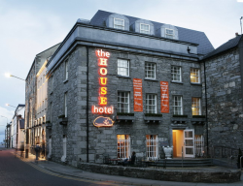 | The House hotel  Spanish Parade  Galway  Ireland  Tel: +353 (91) 538 900  Fax: +353 (91) 568-262  Email: info@thehousehotel.ie

Information for Session Chairs
Session Chairs are chosen on a voluntary basis by proposals by either authors or local committee members or are appointed by the Track Chairs, General Program Chair or General Conference Chair. They are responsible for their assigned session. They make sure their speakers are available, take care of the timing within the session, chair the discussion after each presentation and introduce each speaker based on the CV's given to them by the authors. In case they chair a session featuring extended papers, then they are required to distribute and collect the reviews of that or those papers at the beginning and end of the session. If they have time they should also indicate in their papers the number of session participants.

SEE YOU ALL NEXT YEAR AT
GAMEON 2012

GAMEON'2012
November 12-16, 2012
University of Malaga, Malaga, Spain

Proposals for special tracks/tutorials/demos
can be sent in by September 30th 2011

GALWAY MAP

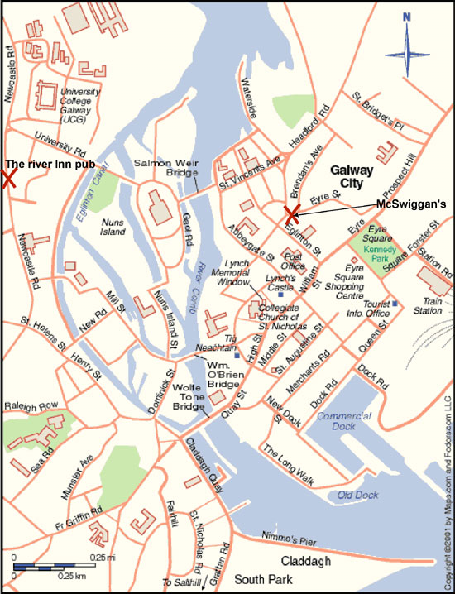

EUROSIS was borne out of discussions with the European Community to set up a new kind of Society, which would be project driven instead of driven by pure membership and conferences.

The aim of the new Society will be to set up topic related Technical Committees which will link directly to European Projects in the field of computer simulation and related areas and to act as a knowledge pool for future European Networks of Excellence, like MOSAIC.

If you would like to receive more information about EUROSIS, please contact

Philippe Geril
EUROSIS-ETI
European Simulation Office
Greenbridge NV
Wetenschapspark 1
Plassendale 1
B- 8400 Ostend
Belgium
Tel: +32.59.255.330
Fax: +32.59.255.339
Email: Philippe.Geril@eurosis.org

Please send me info on EUROSIS:
Name:
Address:

Telephone
Fax:
Email:

